CS/CE 224/272
Object Oriented Programming and Design Methodologies
Project Title
Team Title (as on Canvas) | Group
Team Members’ Details | Name | ID | Section
Team Member 1 | Muhammad Hamza Bin Tariq | 09640 | L3
Team Member 2 | Syed Ahmad Ali Muhammad | 09649 | L3
Team Member 3 | Sarosh Mehdi | 10314 | L3

- Introduction: This project is a 2D game that will be developed in C++ using SFML for graphics and TGUI for the graphical user interface. This game uses OOP principles to develop the environment for the game and develop different gameplay features like movement/dodging,scoring and health tracking. This game is influenced by “Sonic The Hedgehog” game that aims to provide an interactive gaming experience to the user.

- Game / Application Details:
This section describes your project idea in detail.

2.1 Player
The player controls a single Sonic-like character who continuously runs forward through a scrolling 2D environment.
The character can move, jump, and collect items while avoiding hazards.
The player’s movement is handled through the Player class, which manages physics (jumping, movement speed), health, and collision detection.
The sprite representation is created using SFML and responds to keyboard inputs.
The player loses health upon colliding with enemies or obstacles, and the game ends when health reaches zero.

2.2 Scoring System
Scoring is managed by the GameState class.
Players earn points by collecting coins scattered throughout the level.
Each coin adds a fixed value to the total score when collected.
The player’s score increases as they survive longer and collect more coins.
The objective is to achieve the highest possible score before the game ends.

2.3 Power-Ups
A single type of Power-Up appears randomly during gameplay.
When collected, it activates for a limited duration and grants the player a temporary boost (e.g., invincibility, speed increase, health regen).
The PowerUp class manages its activation state, visibility, and countdown timer.
Only one Power-Up can be active at a time, and once its duration expires, the effect is disabled automatically.

2.4 Obstacles
Obstacles act as hazards that reduce the player’s health upon contact.
They are implemented through an abstract base class Obstacle, which defines shared properties such as position, sprite, and collision logic.
Two obstacle types inherit from it:
- Spike – A stationary obstacle placed on the ground.
- FlyingBullet – A moving obstacle that travels horizontally across the screen. It is shot by the enemy entitiy
As the game progresses, the number and speed of obstacles gradually increase, creating a greater challenge for the player.
All active obstacles are managed and updated by the GameState class.

2.5 Enemies
Enemies are moving entities that patrol or appear at random intervals.
They possess health and damage attributes, and can attack the player by shooting bullets (represented by FlyingBullet objects).
If the player collides with an enemy or one of its projectiles, they lose a significant portion of health.
Enemies are managed by the GameState class, which updates their movement, shooting behavior, and collision interactions with the player.

2.6 Game State Management
The GameState class acts as the core controller of the game.
It manages all other components — the player, enemies, obstacles, coins, and power-ups.
It handles the main game loop, including updating all active entities, rendering them, processing input, and detecting collisions.
It also tracks the score, game progress, and end-game conditions (e.g., player death or game over).

- UML Diagram:

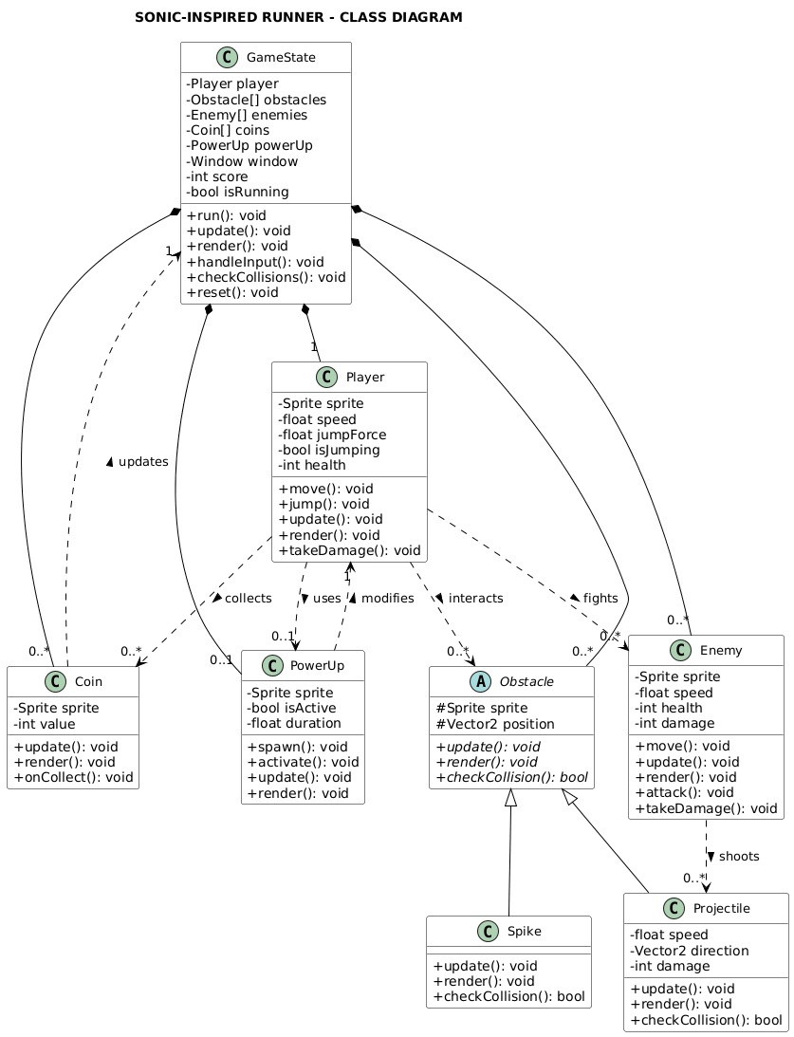

The GameState class acts as the central controller and has composition relationships with key game elements — Player, PowerUp, Obstacle, Enemy, and Coin — indicating that these objects are created and managed by it. Each game run includes exactly one player (1..1) and there can be multiple enemies, powerup, coins, and obstacles active at a time or none (0..* multiplicity).

Obstacle is an abstract base class from which Spike and FlyingBullet inherit, showing a generalization relationship. The player interacts with multiple entities through associations: it can collect multiple coins, activate a single power-up at a time, and collide with multiple obstacles or enemies. Enemies have an aggregation relationship with FlyingBullet, meaning they can shoot multiple bullets that continue to exist independently after being fired.

- Game / Application Screens:
In this section you should describe / draw some sample screens / wireframes for your game / application. Again, you may use any online or installed tool for these screens.

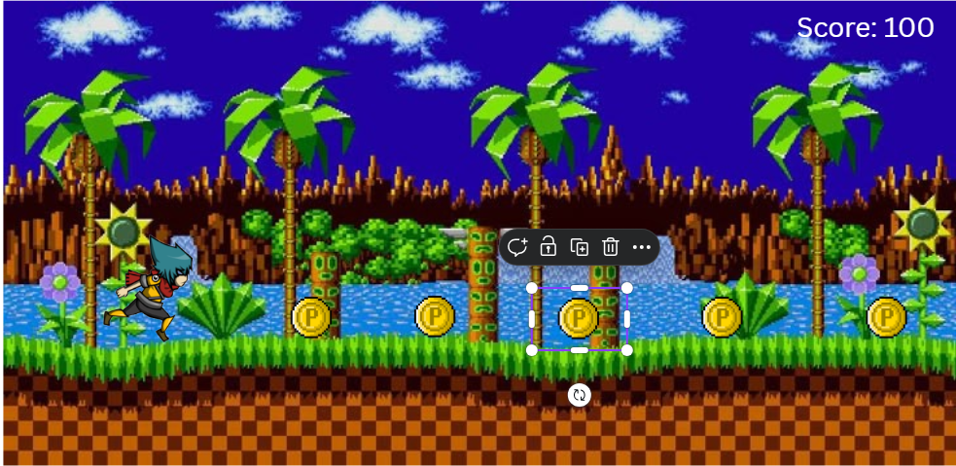
- Mock screen with player running and collecting coins

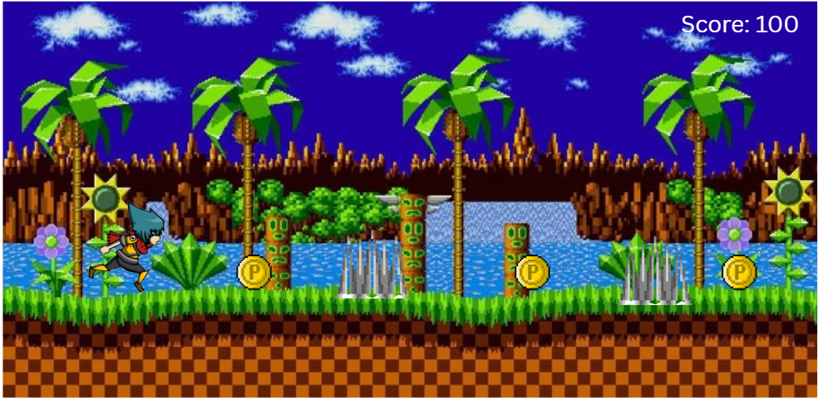
- Mock screen with coins and spike obstacles

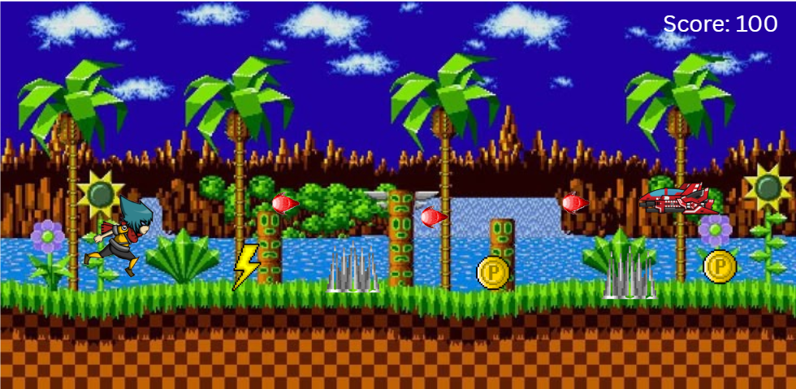
- Mock screens with coins, spikes, powerups, enemy and bullets
Note: These sprites, and background are not finalized and were used as a proof of concept.

